A business client of FedEx wants to deliver urgently a large freight from Denver to Salt Lake City. When asked about the weight of the cargo they could not supply the exact weight, however they have specified that there are total of 36 boxes.

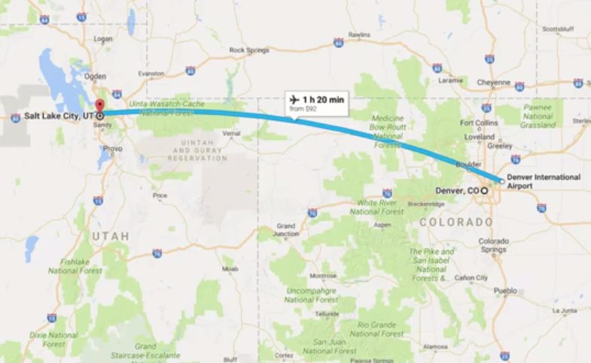You are working as a ****Business analyst**** for FedEx. And you have been challenged to tell the executives quickly whether or not they can do certain delivery.

Denver to Salt Lake City

Since, we have worked with them for so many years and have seen so many freights from them we can confidently say that the type of cargo they follow is a distribution with a mean of μ= 72 lb (32.66 kg) and a standard deviation of σ = 3 lb (1.36 kg).

The plane you have can carry the max cargo weight upto 2640 lb (1193 kg).

Based on this information what is the probability that all of the cargo can be safely loaded onto the planes and transported?

## **The approach:**

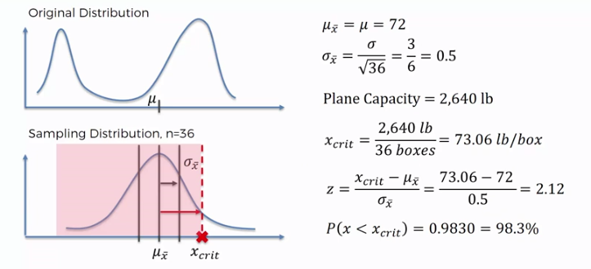

## **Steps:**

· Using CLT, find the mean and std deviation of the sample mean.

· Next, calculate the critical mass (X crit) of each box by dividing the allowable capacity of the plane to carry weight with the total number of boxes. So, to safely takeoff the plane, the average weight of the each box should not exceed 73.06 lb/box.

· Finally, calculate the Z-score from the above formula and then we refer the Z value from the table to find out the probability.